**Doclantic Health Solutions – Project Documentation**1. Introduction

Doclantic Health Solutions is an integrated healthcare platform designed to streamline provider and patient interactions while ensuring secure and efficient health data management. The platform includes:

* Provider Portal – Enables healthcare professionals to manage patient records, appointments, billing, and communication.
* Patient Portal – Allows patients to access their health records, book appointments, and control consent for data access.
* Admin Panel – Facilitates role-based user management and operational control.
* B2B Marketplace – Connects vendors with providers for purchasing hospital supplies.

The platform adheres to FHIR (Fast Healthcare Interoperability Resources) standards and follows HIPAA and   
GDPR compliance for data security.

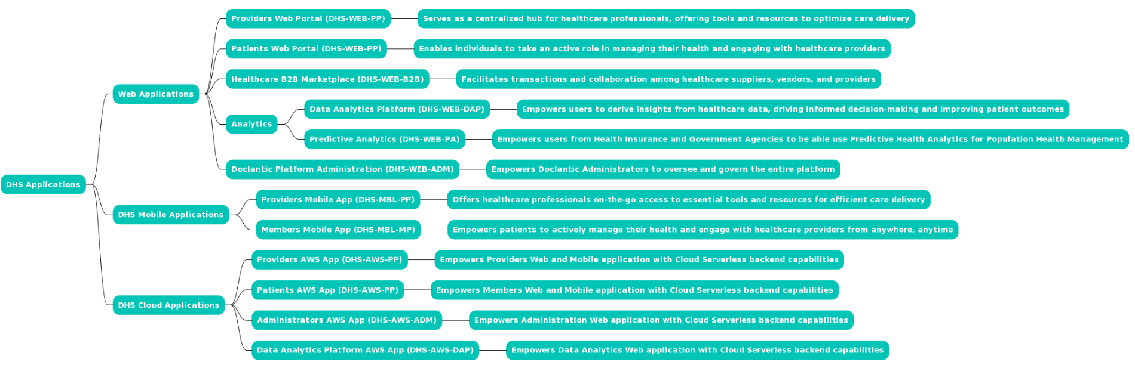

**2. Features & Functionalities**

**2.1 Provider Portal**

The Provider Portal is designed for individual healthcare professionals, clinics, and hospitals, allowing them to efficiently manage patient care.

✅ Provider Registration & Verification

* Providers register using personal and facility details.
* Identity verification ensures only licensed professionals join.

✅ Profile & Facility Management

* Providers can create and manage profiles, facility details, and services offered.
* They can list specializations, working hours, and availability.

✅ Patient Management

* Access and update patient demographics, health records, allergies, lab reports, prescriptions, immunization details, and insurance coverage.
* Maintain encounter records, procedures, and discharge summaries.

✅ Appointment Scheduling

* Patients can book in-person or telehealth appointments.
* Automated reminders reduce no-shows.

✅ Consent-Based Access to Health Records

* Providers must request patient approval before accessing medical records.
* Patients can grant, modify, or revoke consent anytime.

✅ Billing & Payment Processing

* Generate and send invoices.
* Integrated with insurance verification and claim processing.

✅ Communication & Telemedicine

* Secure chat, video consultations, and email communication.

✅ Analytics & Reporting

* Generate reports on patient demographics, treatment trends, and financial insights.

**2.2 Patient Portal**

Patients can easily manage their healthcare needs and control their data.

✅ **Health Record Access**

* View **medical history, prescriptions, lab reports, and immunization records**.

✅ **Appointment Booking & Management**

* Book, reschedule, and cancel appointments.

✅ **Consent Management**

* Control **which providers** can access medical records.

✅ **Communication with Providers**

* Chat, email, and teleconsultation options for remote care.

✅ **Billing & Payments**

* View **invoices**, track **insurance claims**, and make **secure payments**.

**2.3 Admin Panel**

Admins oversee **user management, security, and compliance**.

✅ **User & Role Management**

* Add, edit, and assign **roles (doctor, nurse, receptionist, admin, etc.)**.

✅ **Task Management**

* Assign tasks to healthcare teams and monitor progress.

✅ **Security & Compliance**

* Ensure **HIPAA & GDPR compliance**.

**2.4 B2B Marketplace**

A marketplace for **medical equipment procurement**.

✅ **For Vendors**

* Register businesses and list **medical supplies**.

✅ **For Providers**

* Search, compare, and order **medical supplies in bulk**.

**3. Technology Stack**

|  |  |
| --- | --- |
| **Component** | **Technology** |
| **Frontend** | React.js / Angular |
| **Backend** | Node.js / Django (Python) |
| **Database** | PostgreSQL / MongoDB |
| **API Standards** | FHIR |
| **Security** | HIPAA & GDPR Compliance |

**4. Future Enhancements**

🚀 **AI-powered diagnostics** for predictive healthcare.  
📊 **Wearable device integration** for real-time health tracking.  
📞 **Enhanced telemedicine features** for remote consultations.